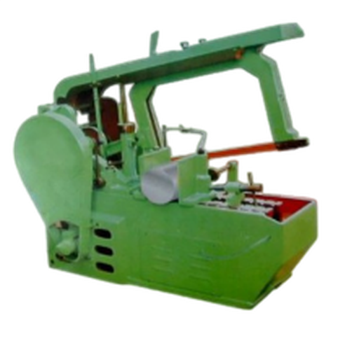

Technical Specifications:
- Cutting capacity :200mm,
- 0.5HP electric motor: 230V/1 phase with combined ON/OFF and safety No- Volt –release switch
- 10 tip blade length :400mm with cutting rate of 80 strokes per Min.
- Motor stops automatically when cutting are complete.
- Liquid coolant /lubrication re-circulating system.
- Integral miter swivel vice for angle cutting
- With accessories: -Open end wrench
-Screwdriver flat head
-Screwdriver Philips head
-Allen key
-Grease gun &tool kit.
- swivel base vise…
- With English operational manual, with training,

